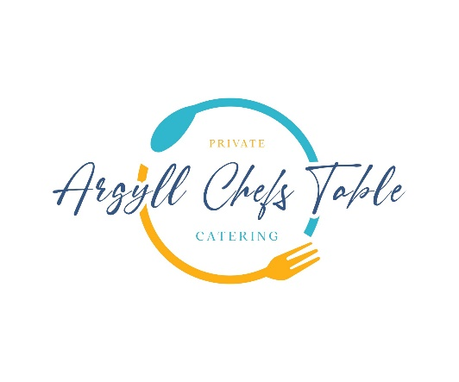

**Spring Menu**

**Freshly Baked Focaccia with Garlic & Dulse Olive Oil**

**Ilse of Mull Scallops**

Stornoway Black Pudding, Chaat Masala Carrot Puree, Wilted Spinach, Chicken Velouté

**Loch Melfort Seatrout**

New Seasons Asparagus, Sauce Gribiche, Fine Herbs

**Roast Cornfed Breast Chicken**

Wild Garlic, Gnocchi, Spring Vegetables

**Rhubarb**

White Chocolate, Stem Ginger, Liquorice



**Qr Code Us & Follow!**