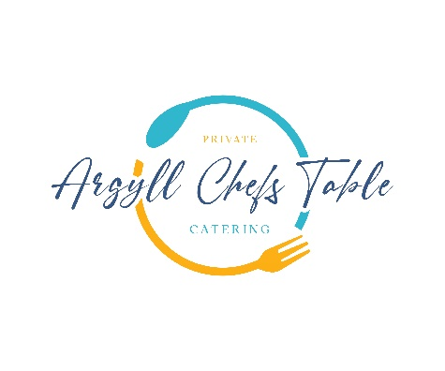

Land & Sea From £115

**Freshly Biga Fermented Focaccia**

Roast Tomato & Scottish Goats Cheese Gratin

**-**

**Loch Creran Oyster**

Oban Whisky Mignonette

**-**

**Hand Dived Isle of Mull Scallops**

Sweet Pea, Chaat Masala, Taynuilt Bacon, Dill Oil

-

**Kinilaw Loch Melfort Seatrout**

Aromatic Coconut Sauce, Curry Leaves, Cucumber

-

**Wild Argyll Venison**

Pickled Berry’s, Chimichurri Sauce

**-**

**Dark Chocolate Mousse**

Raspberry’s, Pedro Ximenez, Pecan, Isle of Gigha Milk Ice Cream