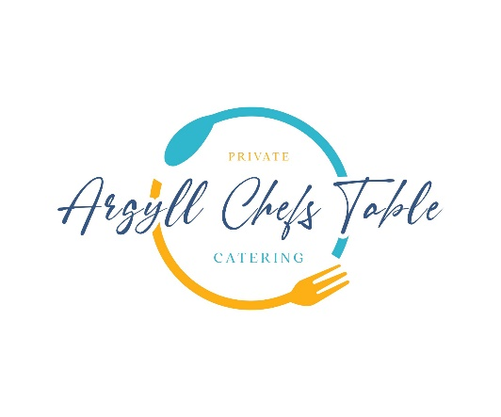

**Winter Menu**

**Freshly Baked Focaccia with Truffled Olive Oil**

**Loch Melfort Seatrout Kinilaw Style**

Lightly Spiced Coconut Sauce, Pickled Vegetables

**Partridge**

Neep Puree, Taynuilt Bacon, Malt Whisky Sauce

**Wild Argyll Venison**

Parsnip Cream, Winter Vegetables, Arran Mustard Jus

**Chocolate Mousse**

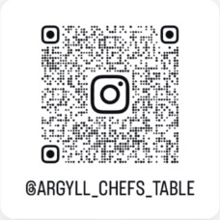Pedro Ximenez, Nut Crumble, Isle of Gigha Ice Cream

**Qr Code Us & Follow!**