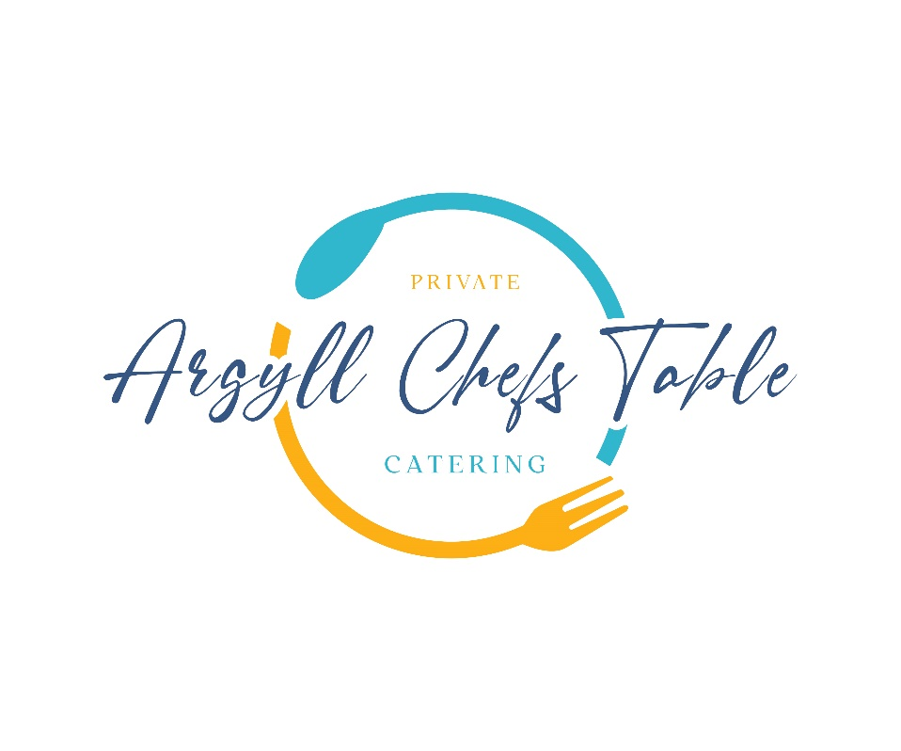

**WINE LIST For every case can be mixed (6 or more bottles 10% off is applied)**

**Whisky Tasting**

Enjoy 3 Specially Selected West Coast of Scotland Whisky’s paired with 3 Scottish Canapes Prior to Your Dining Meal £35pp

**BUBBLES**

Brut Nature Cava, Pago de Tharsys, Utiel-Requena, Spain NV 26

Prosecco Spumante, Fidora, Veneto, Italy NV 26

Extra Brut Crémant Blanc de Blancs, Domaine Schwach, Alsace, France NV 34

Brut Reserve, Billecart-Salmon, Champagne, France NV 76

**WHITE WINES**

Etnia Sauvignon Blanc, Mancura, Cachapoal Valley, Chile 2023 18

Samurai Chardonnay, Free Run Juice, South Australia, Australia 2023 22

Pinot Grigio, Fidora, Veneto, Italy 2022 23

Gewurztraminer Gran Reserva SdV, Morande, Casablanca, Chile 2023 24

Riesling ‘Aromathèque’, Domaine Schwach, Alsace, France 2021 31

Rioja Blanco Crianza, Hacienda Grimón, Rioja, Spain 2020 34

Sauvignon Blanc, Little Beauty, Marlborough, New Zealand 2023 3

Sancerre Blanc, Domaine Pierre Martin, Loire, France 2022 42

Chablis, Domaine de la Meulière, Burgundy, France 2022 43

Chardonnay, Danbury Ridge, England, 2021 74

**RED WINES**

Etnia Merlot, Mancura, Cachapoal Valley, Chile 2022 18

Samurai Shiraz, Free Run Juice, South Australia, Australia 2021 21

Bordeaux Supérieur, Château Lauretan, Bordeaux, France 2015 24

Côtes du Rhône Villages Visan, Domaine Roche-Audran, Rhone, France 2022 26

Montepulciano d’Abruzzo ‘Farae’, Fabulas, Abruzzo, Italy 2022 29

Neprica Primitivo, Tormaresca, Puglia, Italy 2022 31

Rioja Crianza, Hacienda Grimón, Rioja, Spain 2021 30

Pinot Noir, Little Beauty, Marlborough, New Zealand 2021 45

Merlot, Meerlust, Meerlust, South Africa 2018 48

Haut-Médoc, Château Mille Roses, Bordeaux, France 2020 48

Bourgogne Rouge, Domaine Tollot-Beaut, Burgundy, France 2020 60

Pinot Noir, Danbury Ridge, England, 2021 78

Chianti Classico Riserva Tenuta Tignanello, Antinori Marchese, Tuscany, Italy 2021 87

**ROSÉ WINE**

Rioja Rosado, Hacienda Grimón, Rioja, Spain 2023 22

Rosé, Château Grand Boise, Provence, France 2023 35

**SWEET WINE**

Monbazillac (Half bottle), Domaine Ancienne Cure, South West, France 2021 21

Maury (50cl), Domaine Lafage, Roussillon, France 2022 27

Sauternes (Half bottle), Château Filhot, Bordeaux, France 2015 41