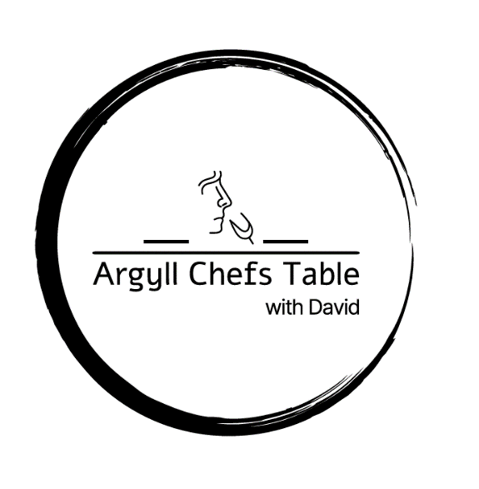

**Festive Menu**

**4- Course**

**From £65pp**

**Fresh Baked Focaccia & Goats Cheese & Tomato Gratin**

Confit Garlic, Rosemary,

**--**

**South Indian Crab & Smoked Salmon Cake**

Scented Coconut Cream

**--**

**Pan Roasted Duck Breast or Chicken Supreme**

Dauphinoise Potato, Winter Vegetables, Red Wine Sauce

Or

**Wild Mushroom Ravioli**

Cured Yolk, Herb Oil, Blue Cheese, Walnuts

**--**

**Dark Chocolate Mousse**

Hazelnut Ice Cream, Pedro Ximenez Gel, Cocoa Tuille

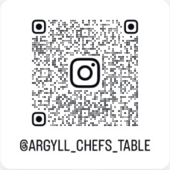

**Qr Code Us & Follow!**