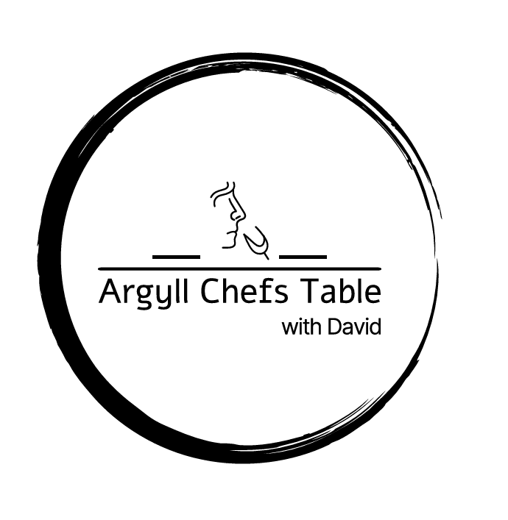

**3 courses from £60pp**

**4 Courses from £80pp**

**Sample Menus**

**Bread**

Fresh Baked Focaccia, with confit garlic, Rosemary

**Starters**

**Haggis Croquette**

Neep Puree, Apple, Oban Whisky Sauce

**Duo of Smoked Trout & Salmon**

Mull Cheddar Scone, Horseradish Crème Fraiche, Pickled Cucumber, Lemon Oil

**Hebridean Blue Tartlet**

Roast Heritage Beetroots, Endive Salad, Sour Cream, Candied Walnuts

**Isle of Mull Scallops**

Taynuilt Bacon, Fresh Peas, Dill, Cappuccino Foam

**Chaat Masala Roast Cauliflower**

Moilee Sauce, Golden Raisins Coriander Chutney

**West Coast Crab Tortelloni**

Bisque, Samphire, Shaved Fennel, Parsley Oil

**St Elrick Goats Cheese**

Sauce Vierge, Shaved Asparagus Salad

**Oban Landed Langoustines**

Garlic, Chilli, EVOO, Parsley, Lemon

**Scotch Beef Carpaccio**

Rocket, Pear, Truffle Oil, EVOO, Corra Linn Cheese, Lemon,

**Main**

**Scottish Dry Aged Sirloin or Fillet of Beef**

Wild Mushroom Ravioli, Asparagus, Red Wine Jus

**Argyll Wild Venison**

Seasonal Vegetable, Wild Mushroom Pithivier, Arran & Game Jus

**Masala Spiced Chicken Supreme**

Spiced Potato Samosa, Tomato Salsa, Coriander Oil

**Grilled Lamb Cutlets**

Confit Potato's, Salsa Verde, Pistachio, Seasonal Vegetables

**Braised Pork Belly**

Pomme Puree, Black Pudding Bon Bon, Seasonal Vegetables, Whisky Café Au Lait

**Baked Lemon Sole Stuffed with Crab**

Warm Tartare Sauce, Asparagus

**Loch Melfort Sea Trout**

West Coast Crab Sauce, Pickled Fennel, Samphire

**Roasted Monkfish & Parma Ham**

Spinach, Pomme Puree, Caper & Lemon Sauce

**Pan Fried Seabass**

Sticky Rice, Spring Onions, Broccoli, Ponzu Sauce, Sesame Oil

**Spinach & Potato Curry**

Chickpea Rice, Coriander, Raita

**Desserts**

**White Chocolate Mousse**

Raspberry Sorbet, Strawberry's, Macadamia Crumb

**Dark Chocolate Mousse**

Amaretto Cherry’s, Isle of Gigha Ice Cream, Cocoa Tuile

**Honey Pannacotta**

Honey Tuile, Strawberry's, Raspberry Sorbet

**Oban Whisky Crème Brulé**

Shortbread, Raspberry's

**Classic Apple Tart Tatin**

Caramel, Madagascan Vanilla Ice Cream

**Scottish Cranachan Tart**

Crème Patisserie, Raspberry’s, Toasted Oats, Oban Whisky, Vanilla Ice Cream

**Sticky Toffee Pudding**

Caramelized Banana, Pecans, Vanilla Ice Cream

**Torched Meringue**

Yuzu Curd, Scottish Berries, Isle of Gigha Ice Cream

**Cheese**

Selection of British Cheese, Homemade Chutney, Local Honey, Crackers, Grapes

**Family Style Sharing**

This Service, fill up your table with a variety of courses, passing & sharing, and conversing with guests. This style works with any size of group whether it is private diner for 10 guests or a wedding for 100+

Select the varieties of options your would like at your event!

**Vegetarian**

Green Beans, Soy, Honey, Fish Sauce, Chilli

Roasted Massaman Cauliflower, Chickpeas, Tahini, Mint, Dill

Vine Tomato, Bufalo Mozzarella, Rocket, Avocado, Balsamic

Roasted Squash, Chilli, Pumpkin, Feta, Coriander

Sardinian Fregola Salad, Radicchio, Mint, Radishes, Chilli, Rocket, Lemon EVOO

Heritage Beetroot Salad, Walnuts, Goats Cheese

Garden Green Salad with Arran Mustard

Blue Cheese, Chicory, Apple, Pecans, Apple Cider Dressing

Grilled Asparagus with Nduja Butter

Creamy Potato Salad, with Dill, Spring Onions

Beetroot Hummus with Crackers

Seasonal Salad with Dijon Dressng

Tropical Fruit Salad, Lime, Coconut

**Fish & Seafood**

Loch Creran Oysters with Mignonette, Tabasco, Lemon

Smoked Salmon, Capers, Shallots, Lemon, Parsley, Mascarpone

Smoked Trout, Artichoke, Pickles, Salad Leaves

Steamed Isle of Mussels, Garlic, White Wine, Cream, Parsley

Seabass, Parma Ham, Green Pesto

Roasted Salmon with Hollandaise, Dill, Lemon

Pil Pil Clams with Garlic, Chilli, Parsley, Olive Oil

Poached Trout Fillet with Warm Tartare Sauce

King Prawns with Chorizo & Fennel

**Meat**

Roast Free Rage Chicken, Rosemary, & Garlic

Lamb Cutlets with Salsa Verde & Walnuts

Chaat Masala Spiced Chicken Bread

Picanha Beef with Salsa Rossa

Breaded Pork Cutlets, Tomato, Capers, Isle of Mull Cheddar

Wild Argyll Venison Loin with Chimichurri

Braised Brisket Burgers with, Spicy Slaw & Pickles

Selection of Meat Tacos, Pico Di Gallo, Poblano Cream