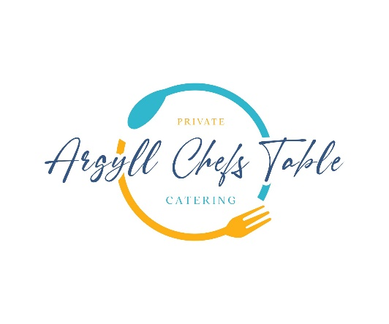

**Summer Menu**

**Freshly Baked Focaccia with Confit Tomato’s & Olive Oil**

**Ilse of Mull Scallops**

Broad Bean Pesto, Pea Puree, Taynuilt Bacon, Chaat Masala

**North Sea Cod Fillet**

Shetland Mussels, Wilted Samphire, Summer Tomato Beurre Blanc, Dill Oil

**Dry Aged Sirloin of Beef**

Garden Chimichurri, Baked Baby Potato Rarebit, Summer Vegetables

**Summer Berry Tart**

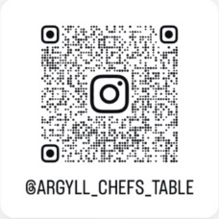Oats, Malt Whisky, Argyll Honey, Crème Patisserie,

**Qr Code Us & Follow!**