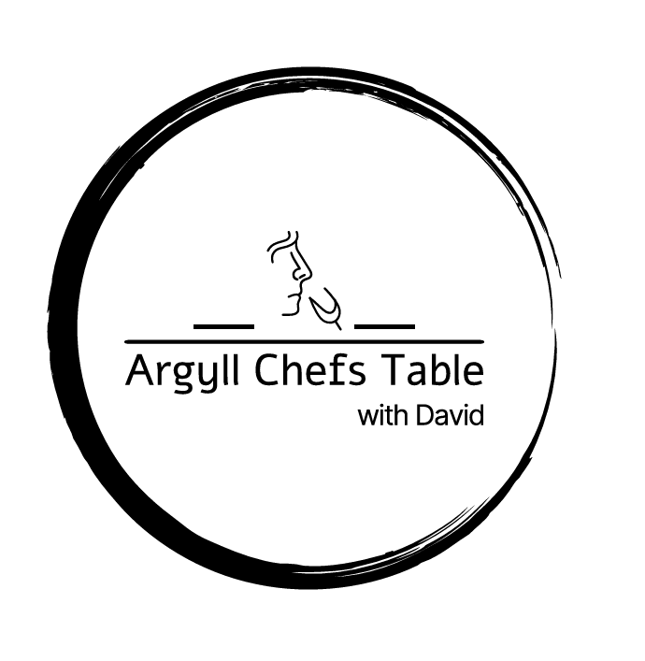

**3 courses from £60pp**

**4 Courses from £80pp**

**Sample Menus**

**Bread**

Fresh Baked Focaccia, with confit garlic, Rosemary

**Starters**

**Haggis Croquette**

Neep Puree, Apple, Oban Whisky Sauce

**Duo of Smoked Trout & Salmon**

Mull Cheddar Scone, Horseradish Crème Fraiche, Pickled Cucumber, Lemon Oil

**Hebridean Blue Tartlet**

Roast Heritage Beetroots, Endive Salad, Sour Cream, Candied Walnuts

**Isle of Mull Scallops**

Taynuilt Bacon, Fresh Peas, Dill, Cappuccino Foam

**Chaat Masala Roast Cauliflower**

Moilee Sauce, Golden Raisins Coriander Chutney

**West Coast Crab Tortelloni**

Bisque, Samphire, Shaved Fennel, Parsley Oil

**St Elrick Goats Cheese**

Sauce Vierge, Shaved Asparagus Salad

**Oban Landed Langoustines**

Garlic, Chilli, EVOO, Parsley, Lemon

**Scotch Beef Carpaccio**

Rocket, Pear, Truffle Oil, EVOO, Corra Linn Cheese, Lemon,

**Main**

**Scottish Dry Aged Sirloin or Fillet of Beef**

Wild Mushroom Ravioli, Asparagus, Red Wine Jus

**Argyll Wild Venison**

Seasonal Vegetable, Wild Mushroom Pithivier, Arran & Game Jus

**Masala Spiced Chicken Supreme**

Spiced Potato Samosa, Tomato Salsa, Coriander Oil

**Grilled Lamb Cutlets**

Confit Potato's, Salsa Verde, Pistachio, Seasonal Vegetables

**Braised Pork Belly**

Pomme Puree, Black Pudding Bon Bon, Seasonal Vegetables, Whisky Café Au Lait

**Baked Lemon Sole Stuffed with Crab**

Warm Tartare Sauce, Asparagus

**Loch Melfort Sea Trout**

West Coast Crab Sauce, Pickled Fennel, Samphire

**Roasted Monkfish & Parma Ham**

Spinach, Pomme Puree, Caper & Lemon Sauce

**Pan Fried Seabass**

Sticky Rice, Spring Onions, Broccoli, Ponzu Sauce, Sesame Oil

**Spinach & Potato Curry**

Chickpea Rice, Coriander, Raita

**Desserts**

**White Chocolate Mousse**

Raspberry Sorbet, Strawberry's, Macadamia Crumb

**Dark Chocolate Mousse**

Amaretto Cherry’s, Isle of Gigha Ice Cream, Cocoa Tuile

**Honey Pannacotta**

Honey Tuile, Strawberry's, Raspberry Sorbet

**Oban Whisky Crème Brulé**

Shortbread, Raspberry's

**Classic Apple Tart Tatin**

Caramel, Madagascan Vanilla Ice Cream

**Scottish Cranachan Tart**

Crème Patisserie, Raspberry’s, Toasted Oats, Oban Whisky, Vanilla Ice Cream

**Sticky Toffee Pudding**

Caramelized Banana, Pecans, Vanilla Ice Cream

**Cheese**

Selection of British Cheese, Homemade Chutney, Local Honey, Crackers, Grapes