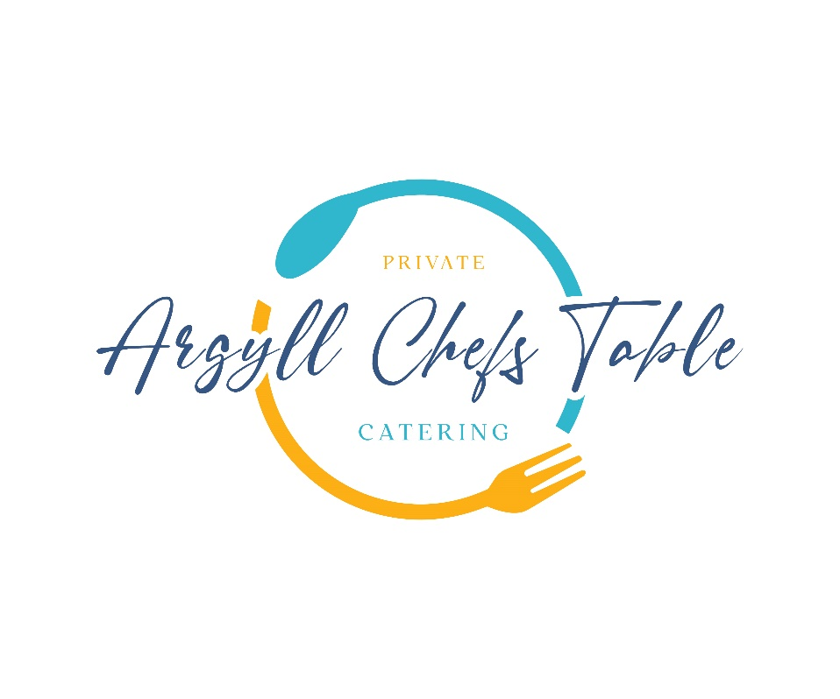

**WINE LIST**

**Whisky Tasting**

Enjoy 3 Specially Selected West Coast of Scotland Whisky’s paired with 3 Scottish Canapes Prior to Your Dining Meal £40pp

**BUBBLES**

Brut Nature Cava, Pago de Tharsys, Utiel-Requena, Spain NV £26

Prosecco Spumante, Fidora, Veneto, Italy NV £26

Extra Brut Crémant Blanc de Blancs, Domaine Schwach, Alsace, France NV £34

Brut Reserve, Billecart-Salmon, Champagne, France NV £76

**WHITE WINES**

Etnia Sauvignon Blanc, Mancura, Cachapoal Valley, Chile 2023 £18

Samurai Chardonnay, Free Run Juice, South Australia, Australia 2023 £22

Pinot Grigio, Fidora, Veneto, Italy 2022 £23

Gewurztraminer Gran Reserva SdV, Morande, Casablanca, Chile 2023 £24

Riesling ‘Aromathèque’, Domaine Schwach, Alsace, France 2021 £31

Rioja Blanco Crianza, Hacienda Grimón, Rioja, Spain 2020 £34

Sauvignon Blanc, Little Beauty, Marlborough, New Zealand 2023 £36

Sancerre Blanc, Domaine Pierre Martin, Loire, France 2022 £42

Chablis, Domaine de la Meulière, Burgundy, France 2022 £43

Chardonnay, Danbury Ridge, England, 2021 £74

**RED WINES**

Etnia Merlot, Mancura, Cachapoal Valley, Chile 2022 £18

Samurai Shiraz, Free Run Juice, South Australia, Australia 2021 £21

Bordeaux Supérieur, Château Lauretan, Bordeaux, France 2015 £24

Côtes du Rhône Villages Visan, Domaine Roche-Audran, Rhone, France 2022 £26

Montepulciano d’Abruzzo ‘Farae’, Fabulas, Abruzzo, Italy 2022 £29

Neprica Primitivo, Tormaresca, Puglia, Italy 2022 £31

Rioja Crianza, Hacienda Grimón, Rioja, Spain 2021 £30

Pinot Noir, Little Beauty, Marlborough, New Zealand 2021 £45

Merlot, Meerlust, Meerlust, South Africa 2018 £48

Haut-Médoc, Château Mille Roses, Bordeaux, France 2020 £48

Bourgogne Rouge, Domaine Tollot-Beaut, Burgundy, France 2020 £60

Pinot Noir, Danbury Ridge, England, 2021 £78

Chianti Classico Riserva Tenuta Tignanello, Antinori Marchese, Tuscany, Italy 2021 £87

**ROSÉ WINE**

Rioja Rosado, Hacienda Grimón, Rioja, Spain 2023 £22

Rosé, Château Grand Boise, Provence, France 2023 £35

**SWEET WINE**

Monbazillac (Half bottle), Domaine Ancienne Cure, South West, France 2021 £21

Maury (50cl), Domaine Lafage, Roussillon, France 2022 £27

Sauternes (Half bottle), Château Filhot, Bordeaux, France 2015 £41