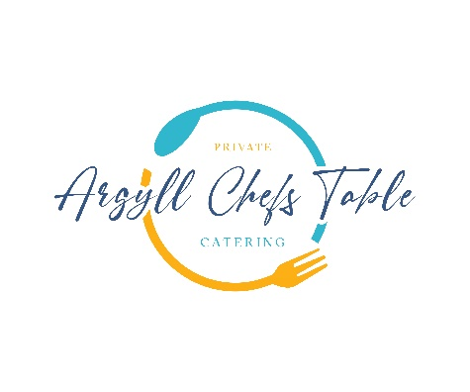

Land & Sea

Sample Menu

**Freshly Biga Fermented Focaccia**

Roast Tomato & Scottish Goats Cheese Gratin

**-**

**Platter of Loch Creran Oysters**

Tabasco, Mignonette, Lemon

**-**

**Hand Dived Isle of Mull Scallops**

Taynuilt Bacon, Parsnip Puree, Pink Grapefruit Beurre Blanc

-

**Pan Fried Wild Bass**

Panzanella Style

-

**Wild Argyll Venison**

Salt Baked Beets, Salsa Verde

**-**

**Dark Chocolate Mousse**

Raspberry’s, Pedro Ximenez, Nut Crumble, Isle of Gigha Milk Ice Cream