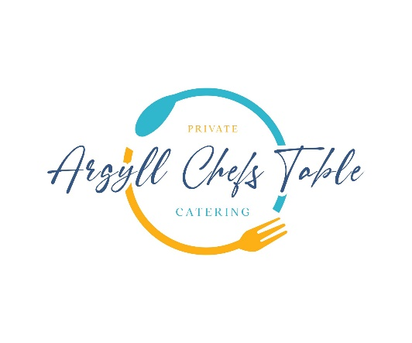

**Autumn Menu**

**Freshly Baked Focaccia with Rosemary & Confit Garlic**

**Steamed In the Shell Scallops**

Confit Leeks, Tarragon, Wild Mushroom

**West Coast Crab Agnolotti**

Mull Cheddar, Shellfish Bisque, Leek Oil

**Wild Argyll Venison**

Pressed Truffled Potato, Chestnuts, Chimichurri

**Plum Pavlova**

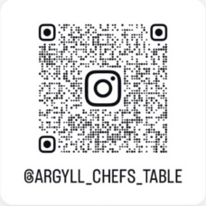Mascarpone Cream, Pistachio, Honey & Whisky Gel

**Qr Code Us & Follow!**