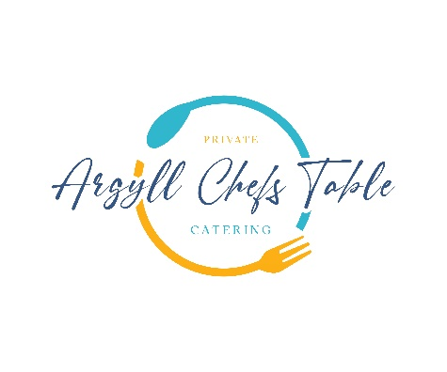

**Canape**

Loch Crearan Oyster with Mignonette

**Freshly Baked Bread with Leek Butter & Sea Salt**

**Ilse of Mull Scallops**

Cullen Skink Velouté, Trout Roe, Wild Garlic

**Wild Argyll Venison**

Pressed Potato, Heritage Carrot, Haggis, Arran Mustard Jus

**Scottish Cranachan**

Raspberry’s, Malt Whisky, Oats, Cream, Local Honey