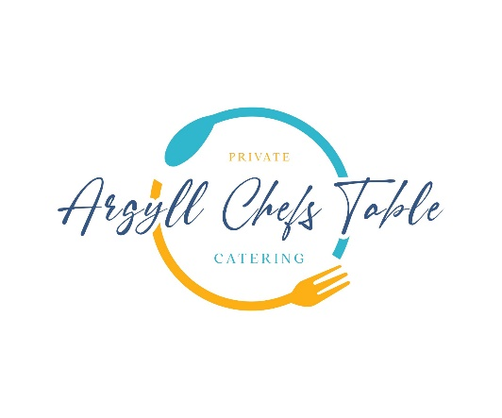

**Summer Menu**

**Freshly Baked Focaccia with Confit Tomato’s & Olive Oil**

**Ilse of Mull Scallops**

Summer Pea’s Taynuilt Bacon, Chicken Jus

**North Sea Cod Fillet**

Shetland Mussels, Wilted Samphire, Warm Tartare Velouté, Dill Oil

**Dry Aged Sirloin of Beef**

Beef Tortelloni, Roasted Onions, Broad Beans, Pan Jus

**Scottish Raspberry’s Cranachan Tart**

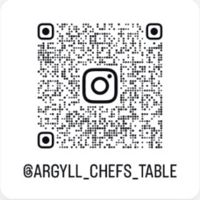Oats, Malt Whisky, Argyll Honey, Crème Patisserie,

**Qr Code Us & Follow!**